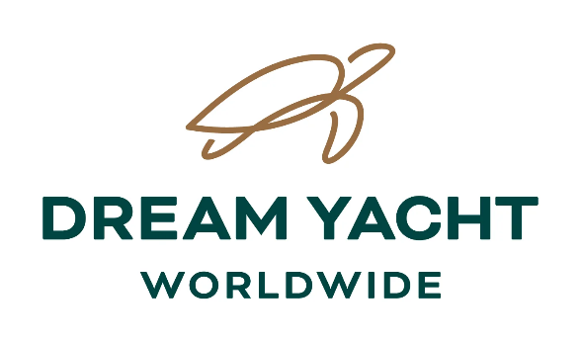
Special Diet requirements *

At Dream Yacht Worldwide, we strive to provide the best service possible. Special diets add a level of complexity for our cooks to prepare great meals for up to 12 guests. There is also a challenge to find the right products in remote destinations where we operate, and substitutions often incur additional expenses. After a full review we will now be able to cater for limited dietary requirements for a small charge.

Dietary alternatives available:

Medical Diet (Gluten-free _____ / Diabetic____)
Cultural Diet (Vegetarian_____/ Vegan_______)
Food Allergies (__________________________)
Pescatarian Diet (_________) (Fish may be frozen)
Food Allergies (__________________________)

**Religious Diet, due to the impossibility of finding special certified products on remote destinations, we do not cater for religious diets & advise clients to choose instead a vegetarian or pescatarian option.
Charges for alternative catering:

- 120 € for 1 week cabin cruise
- 170 € for 10nights cabin cruise (Polynesia Dream & Dream Caribbean cruises)
- 85 € for 4 nights cabin cruise (Rangiroa Dream cruises)
- 75 € for 1 week sail Share (only 1/2 board)

If you require a special diet option, please inform us per above choices, confirming if 1 or 2 special diets are required per cabin. The extra charge will be added to the booking and invoice.

If no extra charge is paid, we will not be able to accommodate any dietary restrictions.

As cabin catering is pre ordered, we ask that requirements be submitted at least two weeks before departure. Last minute requests may not be catered for.

Thank you for choosing Dream Yacht Worldwide. We look forward to providing you with an unforgettable experience. Best regards,

*NB. As menus on cabin charters are pre-set, we are unable to cater for food preferences.

