Tuamutu Papeete Raiatea 3 weeks itinerary

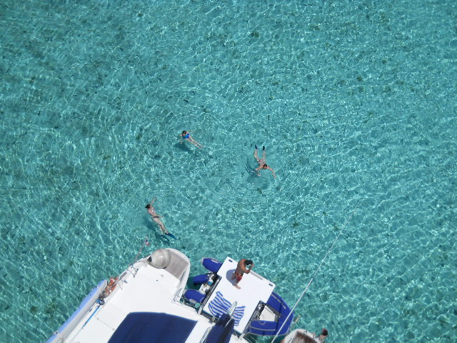
Day 1: Embarkment, paperwork’s, briefing, boat presentation in Papeete Tahiti. Provisioning at the supermarket near the marina.
Day 2 : Day sail to Moorea Cook bay for swiming and snorkeling. dinner ashore at the restaurant
Day 3 : Start in the evening for Rangiroa 200 NM
Day 5: Arrival at the Rangiroa anchor near the pass , relax , swimming and snorkeling
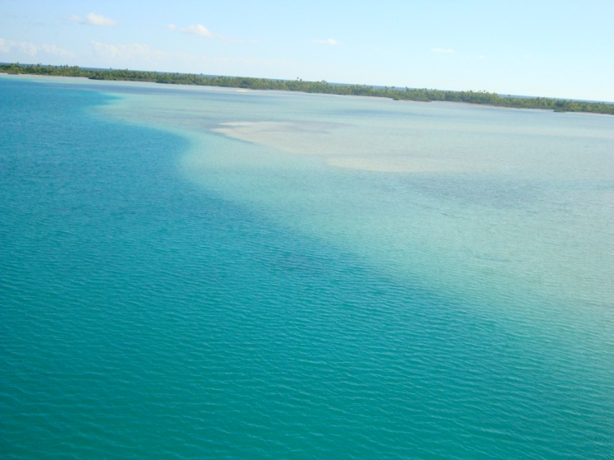

Day 6- 13: Local deckhand embarkment for one week exploring the lagoon
Day 13 : Sail to Tikehau , overnight on anchor in the the inner lagoon of Tuheiava pass.
Day 15 : Early start for the passage to Huahine 190 NM
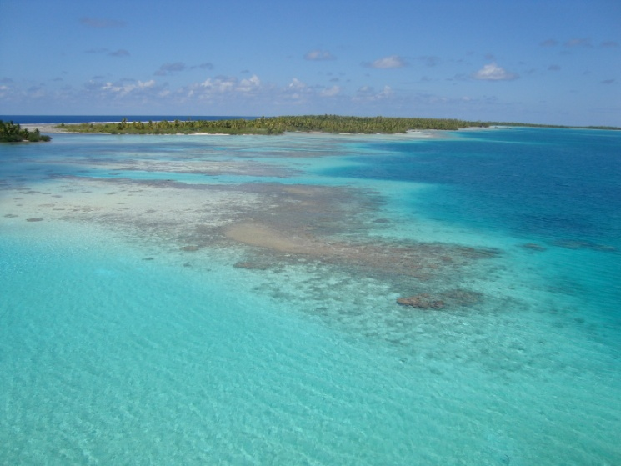
Day 16: Arrival at fare Huahine, restaurant in town

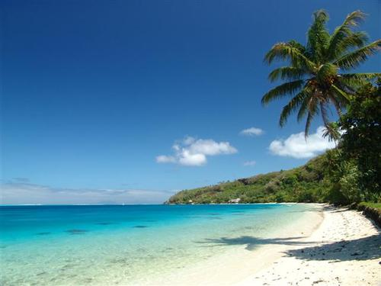
Day 17 to 20 sail the Leeward’s Huahine – Tahaa – Bora Bora- Raiatea

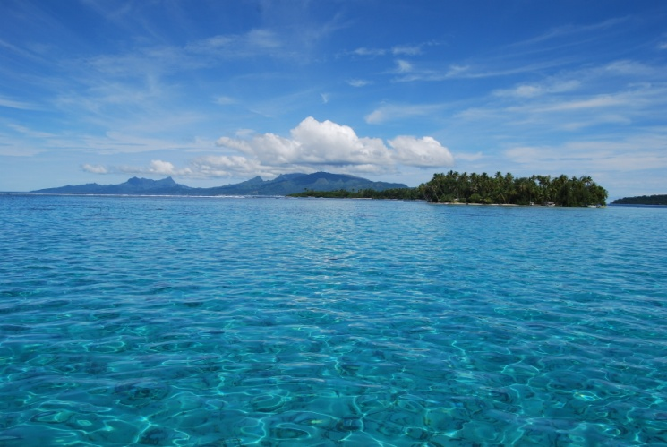
Day 21: Back to the Marina DYC, at 8AM, stopover at the fuel station Total at the entrance of the marina for fuel and diesel refill, then call the base for docking assistance. Debriefing and paperwork at the base.

