Portorosa, Sicily
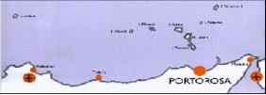

Base Manager: Giovani Denaro

E-mail: sicily@dreamyachtcharter.com

Tel. 39 333 256 6244

Lat : 38° 07' 040’’ N

Long : 15° 06' 072’’ E www.marinadiportorosa.com

We’re glad to remind you that our base is located in the seaside resort of Portorosa, which represents the most favorable starting point to reach the Eolian Islands. Indeed, at only 14 miles sailing rises the enchanting archipelago of the Eolian Islands: Vulcano, Lipari, Salina, Stromboli, Alicudi, Filicudi and Panarea. The following information will certainly render arrangements for your sailing holiday easier, thus we suggest you read it through and do contact us should you have further questions.

Base: Portorosa Villaggio Turistico Portorosa

Office: C/o Turistica Il Gabiano - Residence Laguna Azzurra - Furnari (ME)

Tel. 39 333 256 6244 or +39 348 8102664

Check-in Saturday at 17.00

Check-out Friday at 17.00 + overnight on board until 9.00.

Documents required at the base:

Passports or ID cards if belonging to a EU country - Sailing license (mandatory for bareboat charters) & sailing resume - Crew-list.

Languages spoken at the base: Italian – English – French

Transfers:

For a fast, easy and comfortable journey we highly recommend transfer reservations. Transfers are not included in the charter price. The closest airports to our base are Catania (and Reggio Calabria), about two hours, while it takes about three hours from Palermo. For further details or transfer reservations please contact your agency or our office.

If you wish to travel by train, all timetables and fares can be checked on www.trenitalia.com.

If coming by car, it is possible to park inside the village of Portorosa.

How to reach Portorosa

Catania Airport is 150 km far from Portorosa, Reggio Calabria Airport is 60 km far and Palermo Airport is 210 km far from the marina.

From Catania airport ( www.aeroporto.catania.it)

- Transfer reservation from the airport directly to our base: please contact your sales agent.

- By bus (SAIS – www.saisautolinee.it) from the airport to Messina railway station, and then by train to Barcellona-Castroreale. Finally, by taxi to Portorosa.

- By bus or taxi from the airport to Catania railway station, and then by train to Barcellona-Castroreale

(you have to change train in Messina). Finally, by taxi to Portorosa (about € 40).

From Reggio Calabria airport ( www.sogas.it)

• Transfer reservation from the airport directly to our base: please contact your sales agent.

Alternatively:

- Buses (FEDERICO company) are timed to coincide with national flights for transfers from Reggio Calabria airport to Messina railway station. From Messina to Portorosa you can book a transfer by car or minibus or catch a train to Barcellona-Castroreale. Finally, by taxi to Portorosa.

From Palermo airport ( www.gesap.it)

- Transfer reservation from the airport directly to our base: please contact your sales agent

- Alternatively: By taxi, metro, or bus from the airport to Palermo railway station, and then by train to Barcellona Castroreale. Finally, by taxi to Portorosa.

- By car After crossing the Straits of Messina by ferry (approximate price € 40), follow signs for motorway

(autostrada MESSINA – PALERMO), enter BOCCETTA, go towards Palermo and exit at FALCONE. Finally, take road number SS. 113 towards Messina to Portorosa. The car can be left inside the Village of Portorosa.

- If you wish to rent a car, this is possible with AVIS (c/o HOTEL VALTUR PORTOROSA). You can rent a car at the airport with AVIS and drop it off in Portorosa. For the reservation of car it is preferable that you contact AVIS agency directly and make agreement with them. Local agency Avis Email is: milazzo.v5u@avis-autonoleggio.it

- By shuttle (seasonal service) There is also a shuttle service here in Portorosa, the bus will take you directly from Portorosa to Catania Airport (or from Catania Airport to Portorosa). Ticket price is euro 30/person. There are 4 buses a day (it will take about 2 hours and 30 minutes).

Hints: on your return, if your flight is from Catania and is in the afternoon, you will have enough time to spend in Taormina or Etna before going to the airport. Our office can arrange for you the transfer + a stop in one of these places, time permitting.

Marina Access

Directions:

Enter the entrance gate and turn left. Take the first turn on the right. Go straight ahead. You can park right after the circle drive in front of our office. All our boats are behind the office. Go around the office and down the stairs to the quay (see map below).

Provisioning:

There are some supermarkets inside the Village of Portorosa, which are open from Monday to Saturday, from 8.30 to 13.00 and from 16.30 to 20.00.

Itinerary:

Setting sail from our base in Portorosa for a one week stay, we certainly recommend the Eolian Islands. Upon your arrival, at the check-in, after the boat explanation, our staff will carry out a briefing about ports, moorings, facilities, anchorages, etc. you will find on the Islands.

All clients are given nautical maps and guides necessary for your sailing holiday.

DYC Partnership with Navily
Navily offers a quality service, which allows online marinas booking. It also offers various advises for moorings.
For DYC clients, Navily booking fees (10% of the marina cost) are free for the first night.
https://navily.typeform.com/to/RrAKSu

Eolian Islands:

Climatological Information:
 | Spring | Summer | Autumn | Winter Temperature
Minimum average | °C 13 | 22 | 19 | 11
Maximum average | °C 19 | 30 | 25 | 15
Sea | °C 17 | 26 | 22 | 15
Prevailing winds Direction | NW-SE | NW-NE | NW-SE | NW-W
Average intensity | 2/3 | 1/2 | 3/4 | 4/5
Sunny hours Daily average hours 8 |  | 11 | 7 | 4
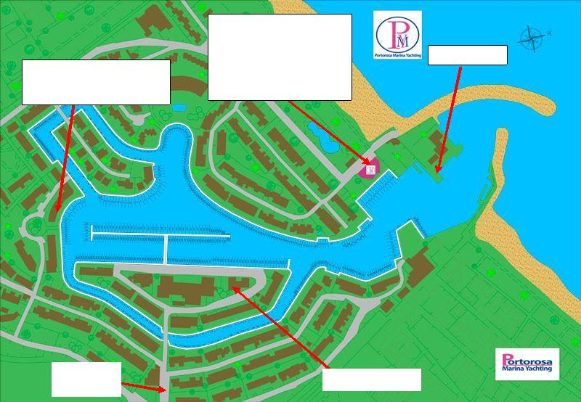

Dream Yacht Charter Office, yachts & Parking C/O Turistica Il Gabbiano
Entrance
Shopping Center
Bancomat

Portorosa Marina Yachting

Showers/WC (entrance by

electronic key only). ^{Fuel Station} Ask reception for the key (20

€ deposit require

