Base Location:
Marina Puerto Del Rey Suite 204
Road No. 3 KM 51.4
Fajardo, PR 00738
Base Information:
Base Manager - Luis Duprey
luis@DreamYachtCharter.com
(786) 205-4664 (787) 534-3393 Fax (787) 534-3404
Office Hours:
8:00 AM – 5:00 PM – 7 Days a week (Late arrivals can proceed to the boat, boat will be ready to board. Marina staff will guide you to your boat. Most of our boats are located on slips 1324 – 1336. See marina map below.
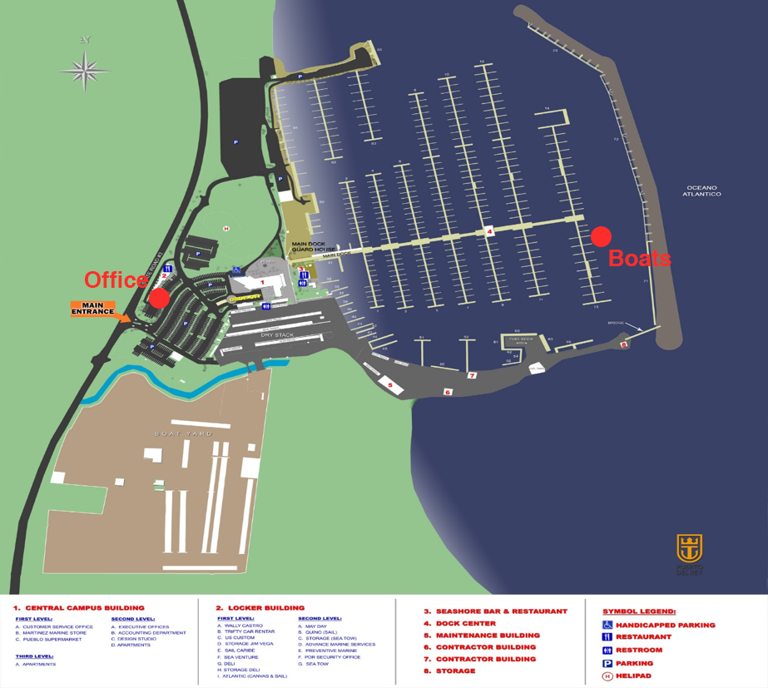
Getting There:
Approximately 35 miles from San Juan International Airport (SJU) Tolls Required – About 45 minutes to 1 hour drive, depending on traffic. Transfer can be scheduled by the base, upon request.
Taxi – Airport to Fajardo - $85.00 - $95.00
Private Transportation - $100 - $150
Luxury ground and air (helicopter) transportation – Contact Base for Details.
Commonwealth of Puerto Rico:
U.S Territory – San Juan International Airport Code: SJU
US Currency – Dollar $
All major credit cards accepted:
Visa, Master Card, Amex, Discovery.
International Travelers verify US visa requirements.
US Citizens – Passport required if sailing to US Virgin Islands and British Virgin Islands.
US Customs – SJU (787) 729-6840 Fajardo (787) 863-0950
US Customs Toll Free: 1 -800-432-1216
Charterer will be instructed on how to clear US Customs during briefing.
Provisioning:
Puerto Rico Yacht Provisioning https://www.puertoricoyp.com/
PRYP – See provisions list on FORMS sections (Download)
Natalia Rovira - (787) 529-6565
Communications:
Most US cellphone carriers extend service to Puerto Rico however you’ll need to verify with your service provider coverage and or roaming charges. Good cellphone coverage throughout all the Spanish Virgin Islands. Free WIFI available throughout the marina facilities.
Near By Stores:
*Ralph’s Food Warehouse *West Marine *CVS
*WalMart *Skipper Shop * Others ….
*Amigo Supermarket *Sam’s Club
*Econo Supermarket *Walgreens

On Site Amenities
- Concierge Services
- Laundry
- Marina Golf car transport (contact Marina via VHF 71)
- -Ice
- -Fuel
- -Free Wi-Fi
- -Free Cable TV
- - Showers -Concierge Service
- -Deli, Bar & Restaurant La Cueva Del Mar (Restaurant on site)
- -Marine Store
- -Children’s Jungle Gym
- -Game Room
- -The marina also has a limited number of one and two bedroom apartments available for rent.
- Car Rental at airport and on site.

Snorkeling Gear and water toys:
Dream Yacht Charter provides all snorkeling gear (fins, mask & snorkel)
Very limited amount of children sizes please contact the base for specific sizes if necessary
Paddle Boards, kayaks, watercrafts and scuba gear can be rented on daily/ weekly basis. Contact base for more details.
Weather:
VHF Spanish / English
http://www.weather.gov/sju/marine
https://www.wunderground.com/US/PR
https://www.seatow.com/local/puertorico/

